**How to deploying web application in apache2**

First We created instance and we take IP in the instance.

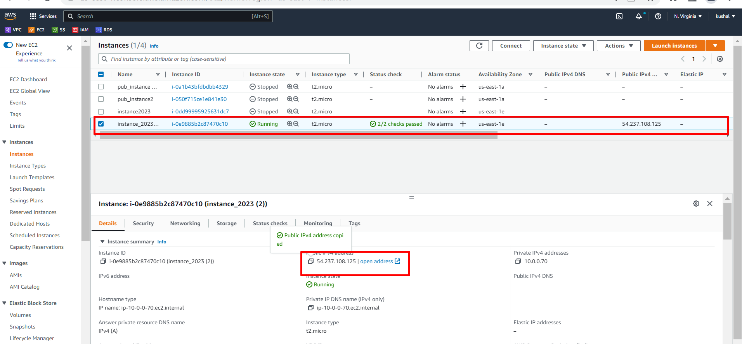

Next we login into mobaxterm.

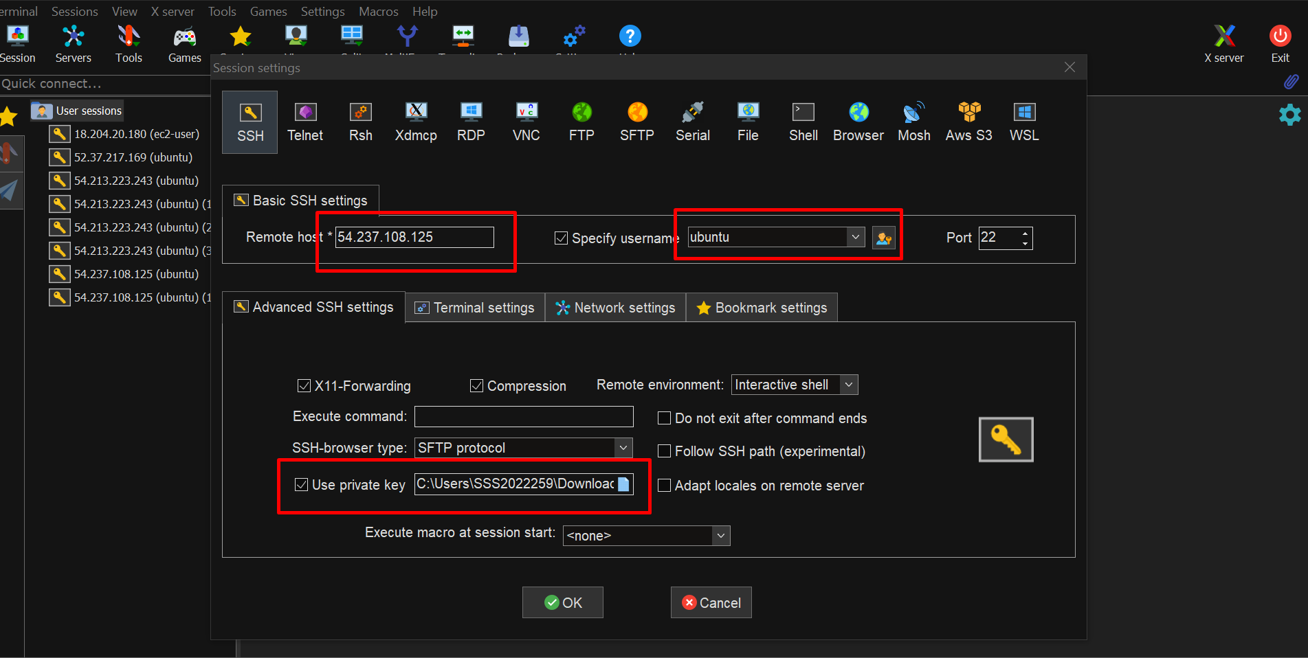

Login successfully.

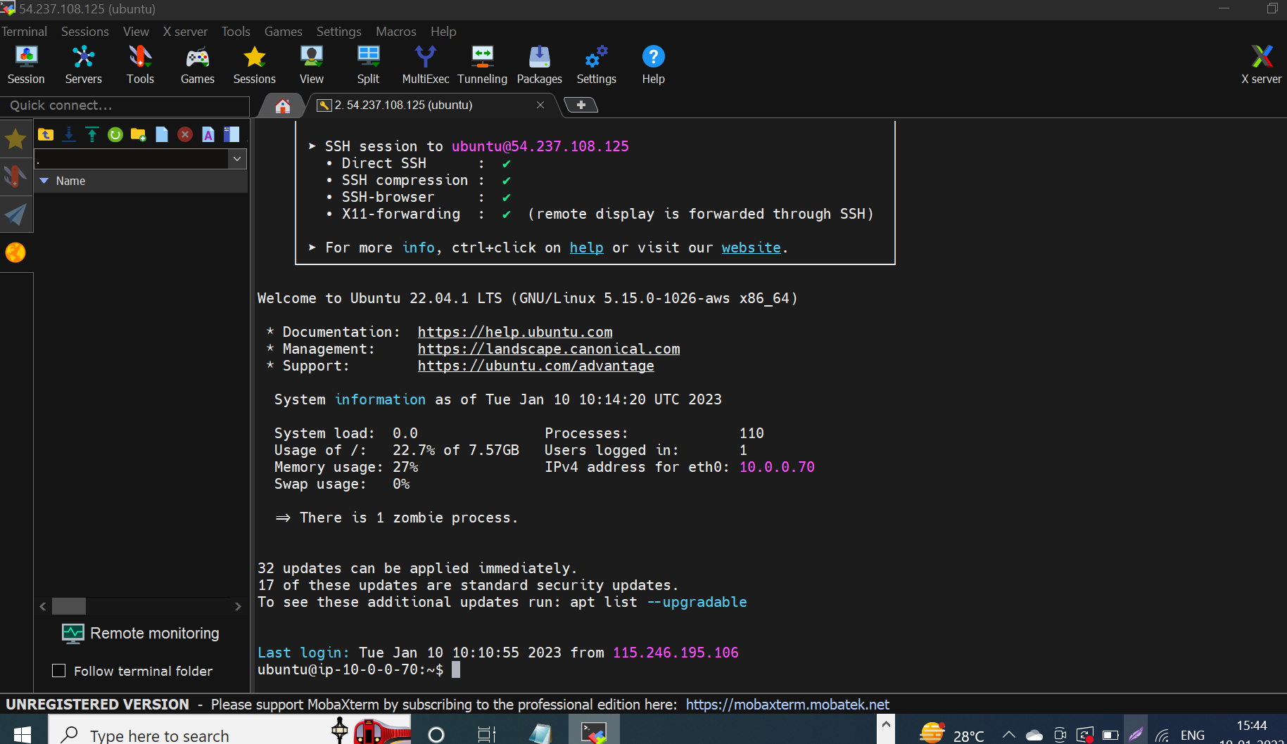

Next we install apache2 in mobaxterm so first we update that app

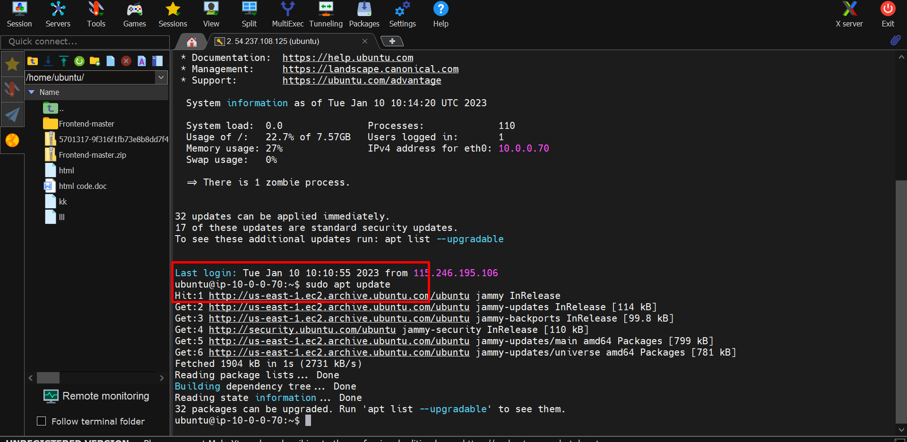

Next we install apache2

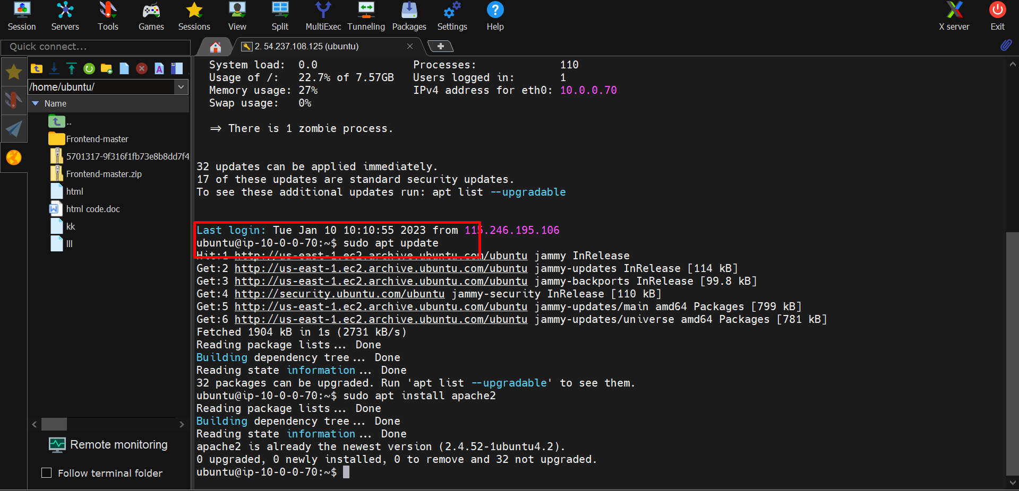

Next we check status

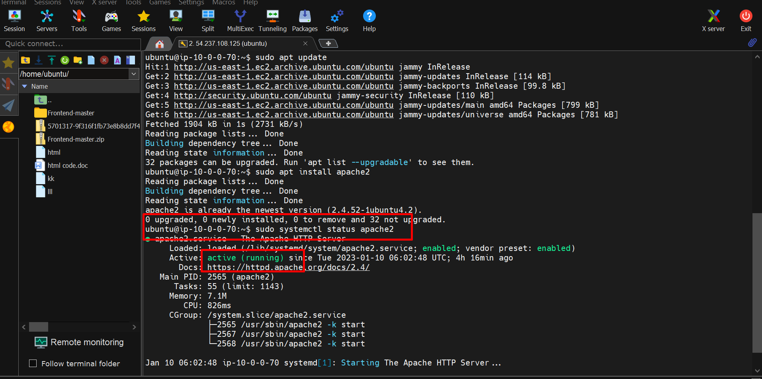

Next we copy the html code in web and next we copy the code in command.

Next we go to apache2 path (cd /var/www/html).

**Commnads:-**

* Sudo git init
* Sudo git pull copy the web URL

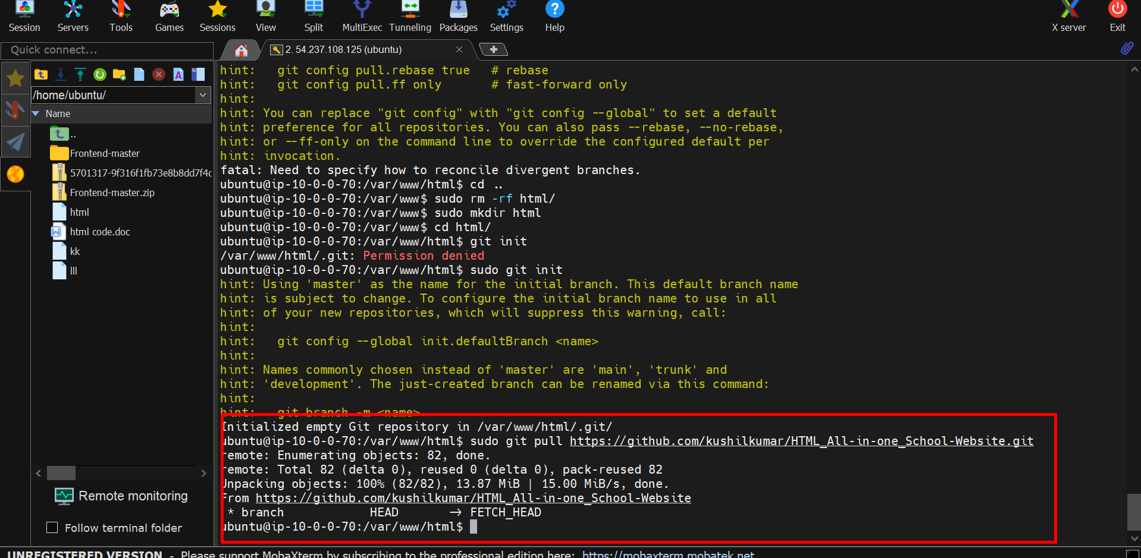

Next we can move that file into another path and unzip that file by using this command

Mv filename /pathname

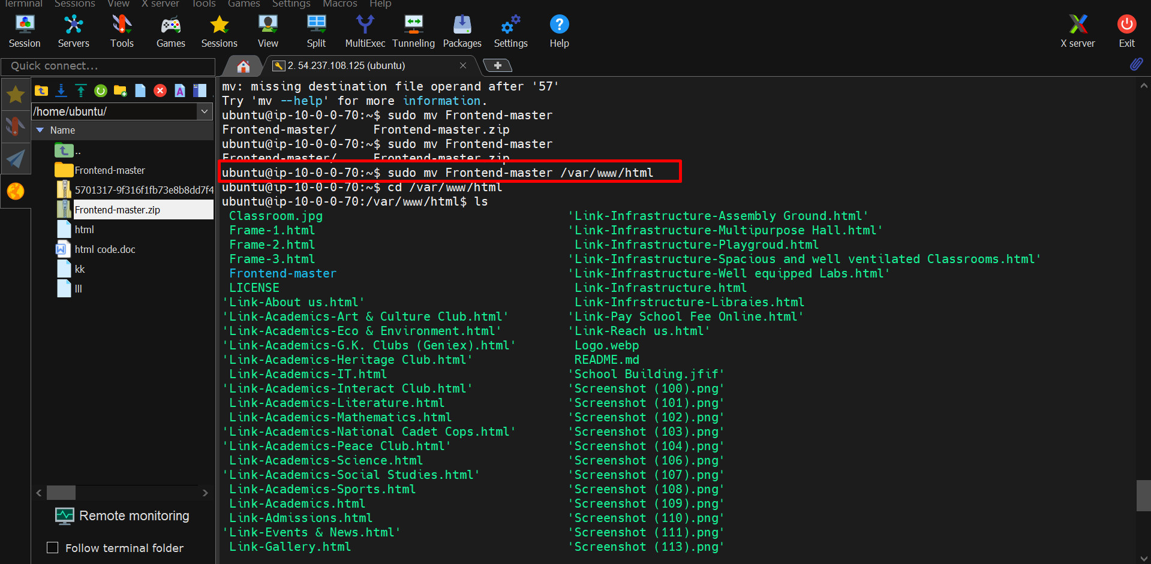

Next we copy the IP in instances and paste in web browser.

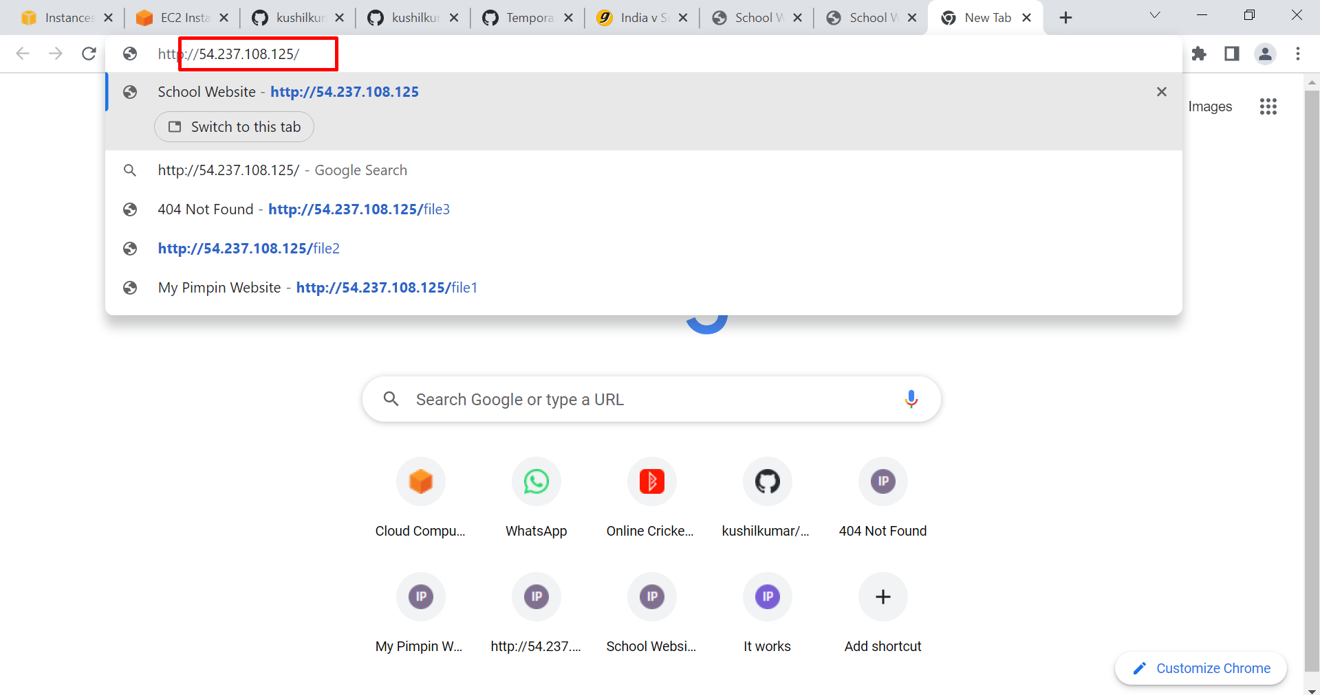

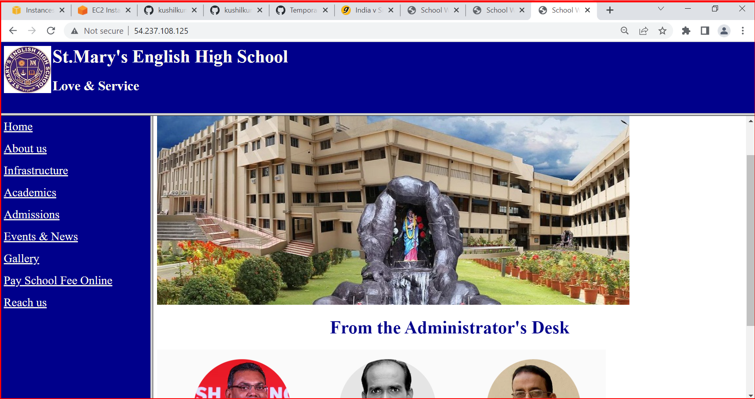

Finally we successfully deploying web application in apache2.